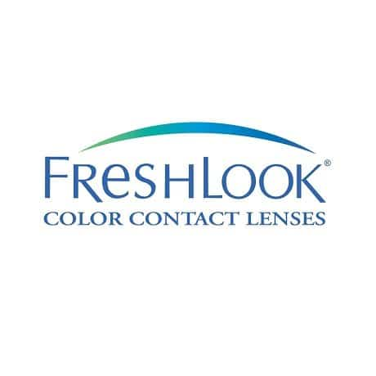

ColorBlends Monthly Contact Lenses

**$ 110**

FreshLook Colorblends are monthly coloured contact lenses by Alcon & Ciba Vision. Whether you’re after a subtle eye colour update or are wanting to turn heads with a more dramatic change, achieve your desired look with these exceptional coloured lenses.

FreshLook Colorblends utilise 3-in-1 colour blend technology for a natural looking colour. It innovatively blends three different shades together and mimics the varying tones of your iris.

The FreshLook Colorblends range comes in 12 colours. Grey, Green or Brown provide a gentle enhancement for light coloured eyes, while Blue, Pure Hazel and Honey are a great choice of FreshLook Colorblends contacts for dark brown eyes. For those after an entirely fresh look, Brilliant Blue, Gemstone Green, True Sapphire, Sterling Grey or Amethyst offer a more striking update.

If you want contact lenses purely for cosmetic use, these high-quality coloured contacts are available in plano (zero prescription) form. Even if it’s for cosmetic purposes, you should check with your eye care professional to see if FreshLook Colorblends are suitable for you.

FreshLook Colorblends contact lenses deliver an unparalleled performance, freshness and comfort, that doesn’t change throughout the day. Made with a 55% water content, these lenses hydrate your eyes over the course of the day. FreshLook Colorblends prevent the onset of dry eyes and keep them moist all day long. As a result, clear and comfortable vision is delivered from the start of the day to the end of it with these high-quality monthly contact lenses.

